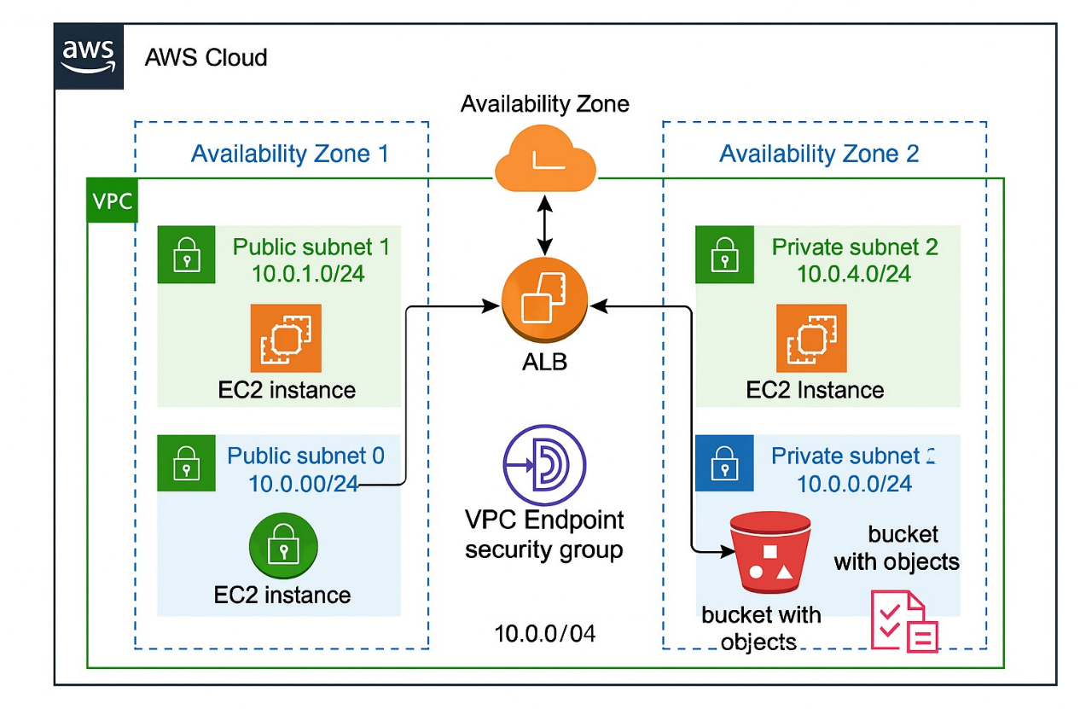

**1)VPC CREATION:**

**Step 1: Go to the VPC Dashboard**

* In the AWS Console, go to VPC.
* Click “Your VPCs” in the left-hand menu.
* Click the “Create VPC” button.

**Step 2: Choose VPC Creation Method**

* Choose “VPC only”

**Step 3: Configure VPC Settings**

* Name tag: (e.g., myvp)
* IPv4 CIDR block: (e.g., 10.0.0.0/16)

**Click Create VPC.**

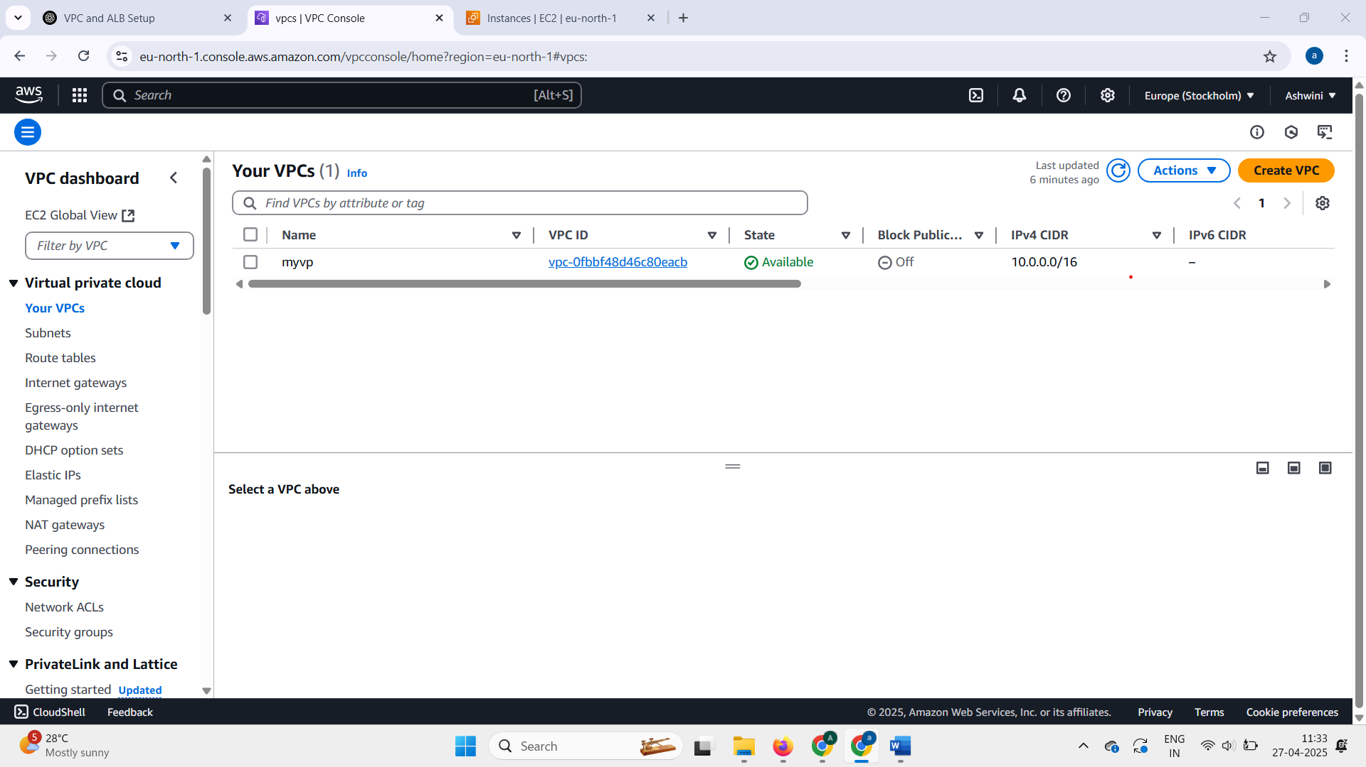

2)SUBNET CREATION:

Step 1: go to **Subnets** → Click **Create Subnet**.

Step 2: In the Create Subnet page:

* **Select your VPC**.
* Create your **first subnet**:
  + **Name**: (e.g., Public Subnet 1)
  + **AZ**: Choose (eu-north-1a)
  + **CIDR block**: e.g., 10.0.1.0/24
* Click **Add another subnet** (on same page):
  + **Name**: (e.g., Private Subnet 1)
  + **AZ**: Choose (eu-north-1a)
  + **CIDR block**: e.g., 10.0.2.0/24
* Click **Add another subnet** (on same page):
  + **Name**: (e.g., Public Subnet 2)
  + **AZ**: Choose (eu-north-1b)
  + **CIDR block**: e.g., 10.0.3.0/24
* Click **Add another subnet** (on same page):
  + **Name**: (e.g., Private Subnet 2)
  + **AZ**: Choose (eu-north-1b)
  + **CIDR block**: e.g., 10.0.4.0/24

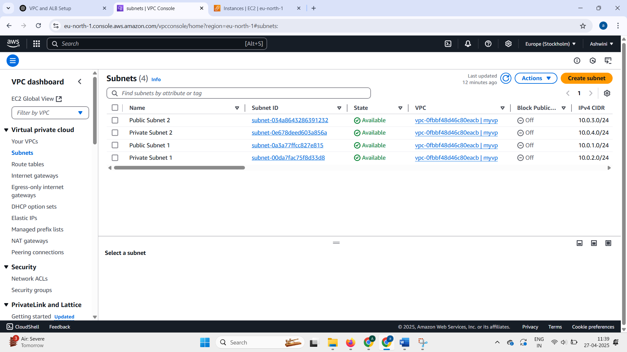

3)EC2 INSTANCE CREATION:

**Step 1: Go to the EC2 Dashboard**

* In the AWS Console, go to **EC2**.
* Click **“Instances”** in the left menu.
* Click the **“Launch Instance”** button.

**Step 2: Configure Basic Settings**

**1. Name:**

* Give your instance a name (e.g., myec2)

**2. Application and OS Image (AMI):**

* Choose Ubuntu

**3. Instance Type:**

* Select t3.micro (free tier eligible)

**4. Key Pair (Login):**

* Create or choose an existing key pair(e.g, webserver)

**5.Network Settings:**

* **VPC**: Choose the VPC you created (myvp)
* **Subnet**: Pick a subnet within that VPC
* **Auto-assign Public IP**: Set to **Disable** if you don’t want internet access
* **Firewall (security group)**:
  + Select an existing group(e.g, default)

**Step 3: Launch**

* Click **“Launch Instance”**

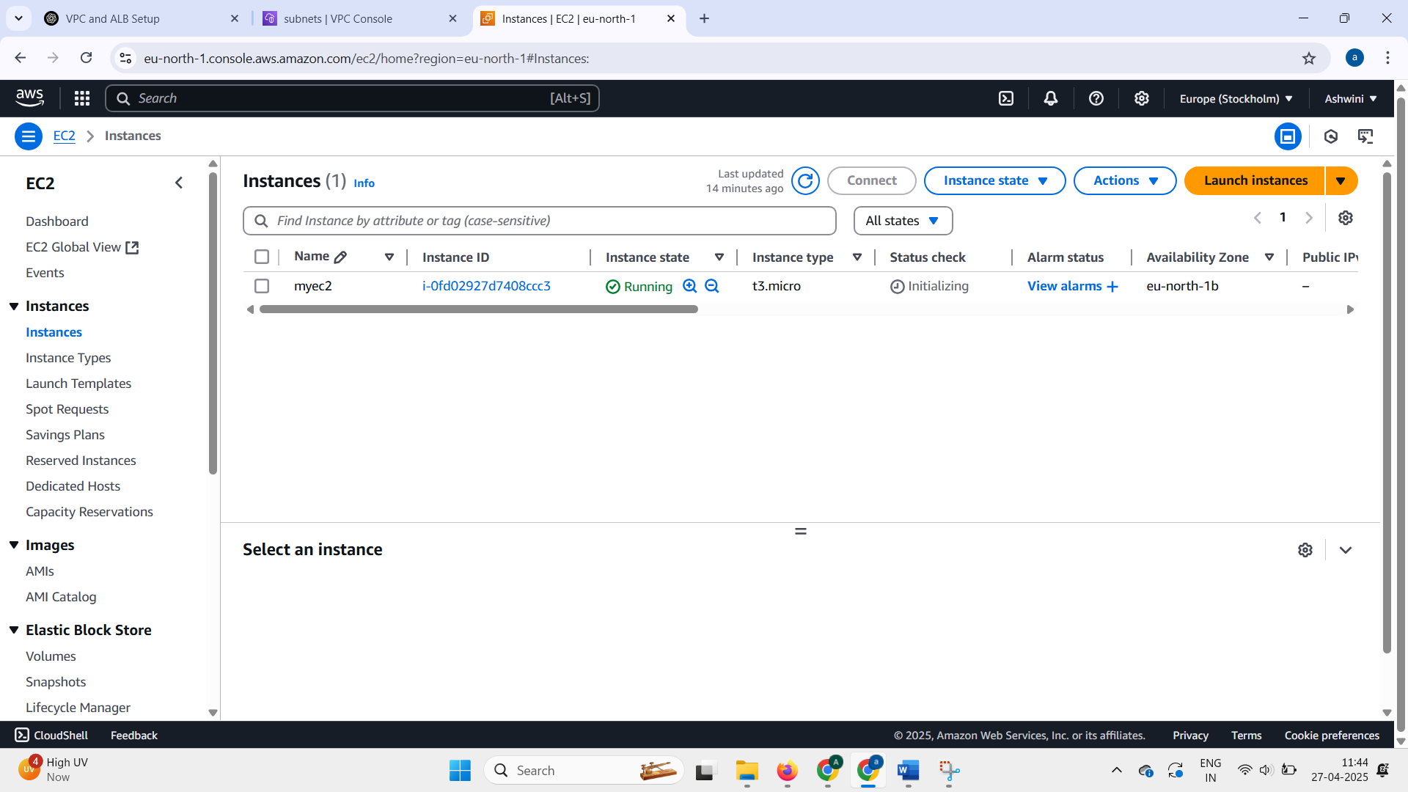

4) VPC ENDPOINT FOR S3:

Step 1:**Go to the VPC Dashboard:**

* In the AWS Console, go to **VPC**.
* Click on **Endpoints** in the left menu.
* Click **Create Endpoint**.

2:name tag(e.g, myendpoint)

3:**Choose Service Category:**

* Select **AWS services**.

4:**Find the S3 Service:**

* In the **Service Name** section, search for the **S3 service** specific to your region.
* In the **Service Name** list, it should look like:  
  com.amazonaws.<region>.s3  
  (Example: com.amazonaws.eu-north-1.s3)

5: **Configure the Endpoint:**

* + **VPC**: Choose the VPC that your EC2 instance resides in.
  + **Route Tables**: Choose the route tables for the subnets that need access to S3.
  + **Policy**: Either choose the default full access or create a custom policy.

**6: Create the Endpoint**:

* + Click **Create Endpoint**.
  + 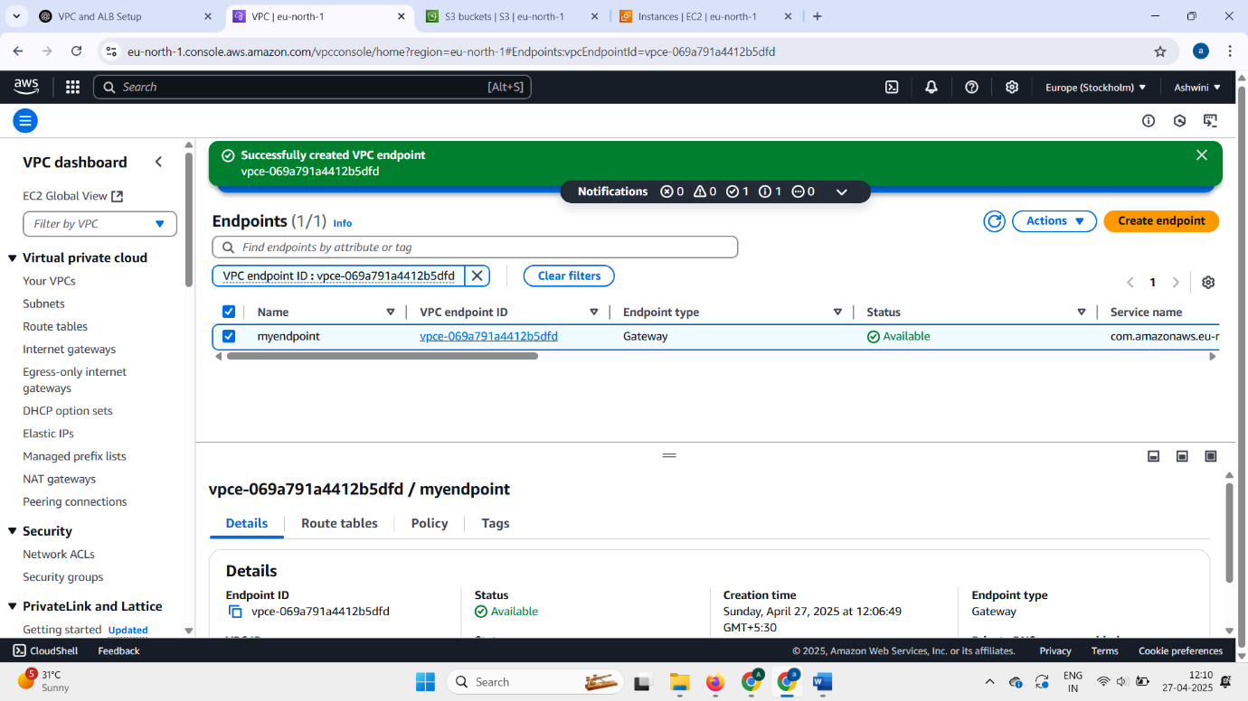The VPC endpoint will now be available and route traffic from EC2 to S3 without leaving the AWS network.

**Step 2: Configure Security Groups for EC2**

1. **Go to EC2 Dashboard:**
   * Navigate to **EC2 > Instances**.
   * Select your EC2 instance.
2. **Modify Security Group:**
   * In the **Security** tab, click on the **Security Group ID**.
   * 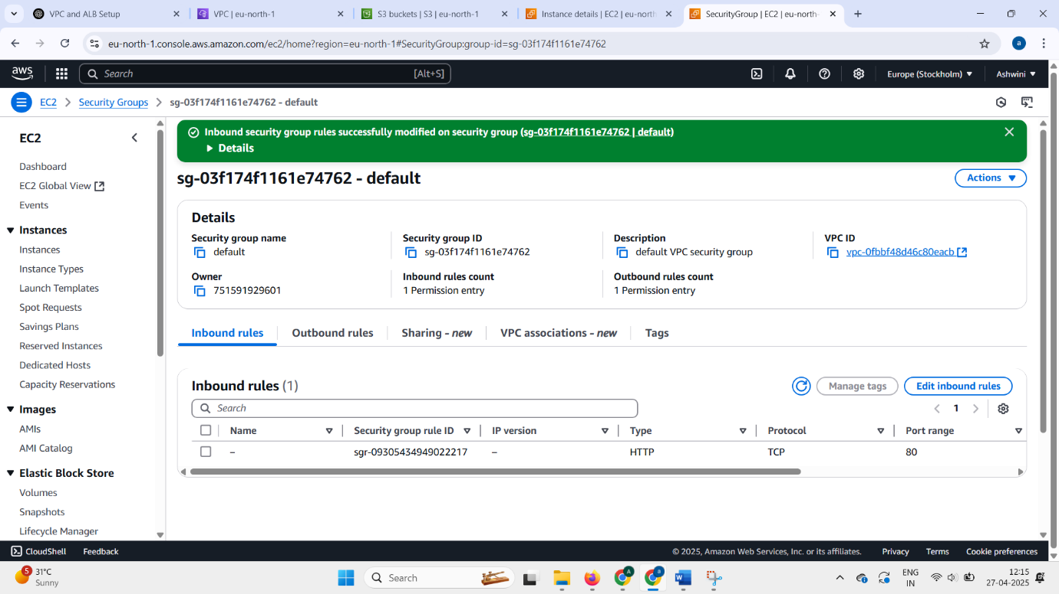Go to **Inbound Rules** and ensure that **Port 80** (HTTP) or **Port 443** (HTTPS) is open for communication.
3. **Outbound Rules**:
   * Outbound traffic is allowed by default, but verify that the EC2 instance can communicate with the VPC endpoint.

**Step 3: Configure S3 Bucket Policy**

1. **Go to S3 Dashboard**:
   * In the AWS Console, navigate to **S3**.
   * Select the **S3 bucket** you want your EC2 instance to access.
2. **Edit Bucket Policy**:
   * Click on the **Permissions** tab.
   * Scroll down to **Bucket Policy** and click **Edit**.
3. **Add a Bucket Policy for VPC Endpoint Access**: To ensure that only traffic from your VPC and VPC endpoint can access the S3 bucket, you need to create a policy restricting access.

Example bucket policy:

{

"Version": "2012-10-17",

"Statement": [

{

"Effect": "Allow",

"Principal": "*",

"Action": "s3:GetObject",

"Resource": "arn:aws:s3:::buck.my/*",# REPLACE

"Condition": {

"StringEquals": {

"aws:SourceVpc": " vpc-0fbbf48d46c80eacb"# REPLACE

}

}

}

]

}

1. **Save the Policy**:

* Click **Save** to apply the policy.

5) Set up ALB (Application Load Balancer)

1.Go to **EC2 Dashboard** → **Load Balancers** → **Create Load Balancer** → **Application Load Balancer**.

**Fill details:**

* **Name**: myalb.
* **Scheme**: **Internet-facing**
* **IP address type**: IPv4.
* **Listeners**: Create listener for HTTP on port 80.

**2.Configure Availability Zones**

* **Select your VPC**(myvp)
* **Tick both Public Subnets**:
  + Public Subnet 1 (AZ1)
  + Public Subnet 2 (AZ2)

**3.Configure Security Group for ALB**

* Allow **inbound HTTP (80)**
* Outbound can stay default (allow all).

**4. Attach Target Group**

* In "Listeners" section:
  + 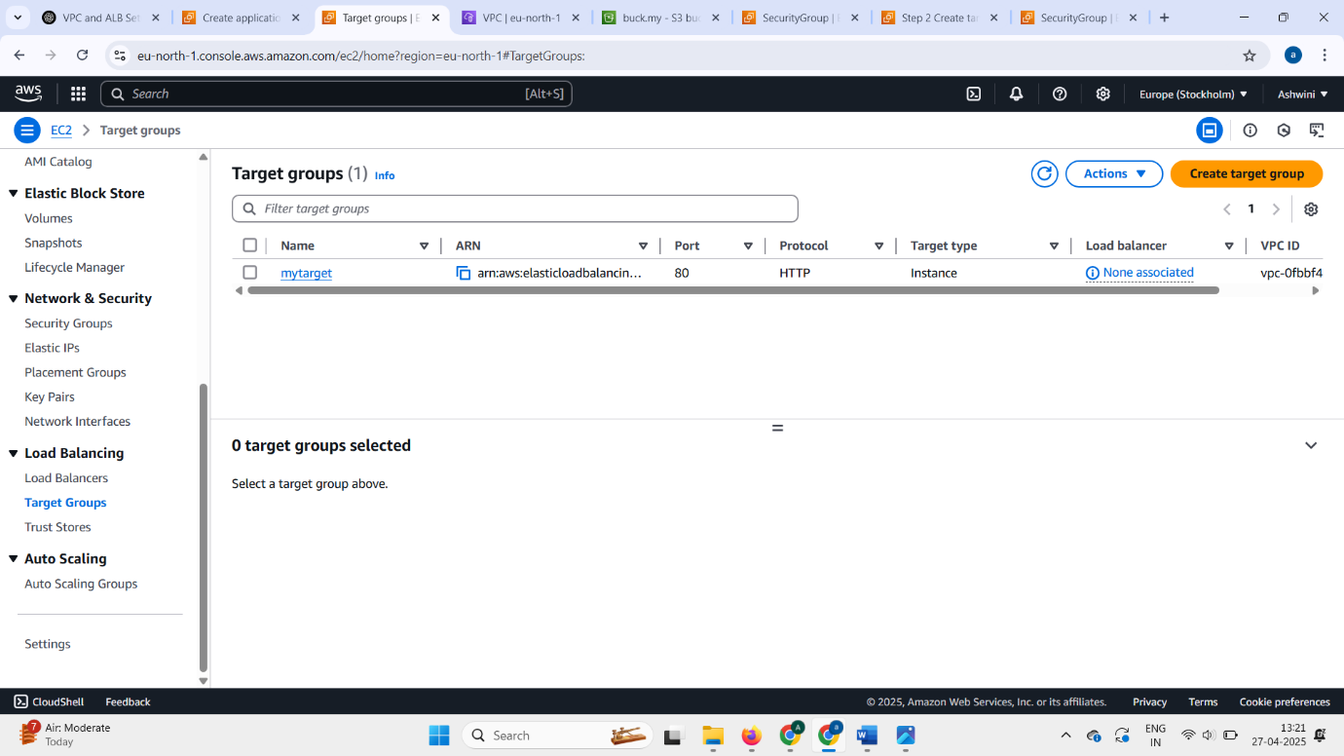Forward traffic to your **Target Group** you created earlier.

1. **Review and Create**

* Review all settings.
* 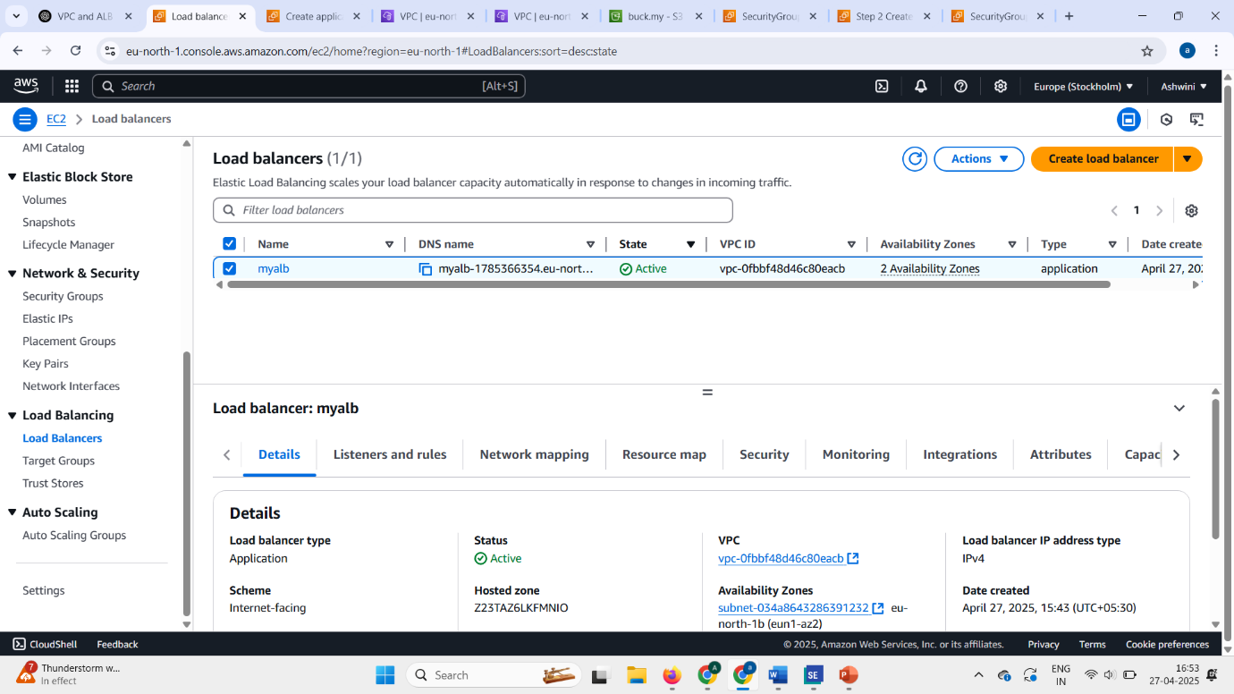Click **Create Load Balancer**.